21st November 2024

Model Renovation Package
What is a Model Renovation Package?

The aim of the Model Renovation Package is to provide a step-by-step guidance, which a HOMAB (=Home-Owned-Multi-Apartment-Buildings) needs to be inspired, how to identify and implement the existing renovation needs of the building. The Model offers practical advises in the form of visual and easy understandable process chart, what details the decision makers (i.e board chairmen and board members) of HOMAB shall be clarified in cooperation with their building manager. The Model facilitates to understand the idea of group procurement, i.e. how HOMABs are able to gain economical advance and save money by achieving cheaper unit prices. The model supports the implementation of group procurements especially when several HOMABs (mostly in the same age) have similar renovation, energy efficiency or renewable energy targets.

The Model Renovation Package has been piloted and tested by the city of Lappeenranta, Finland. The city of Lappeenranta provides the energy advisor services as OSS (=One Stop Shop) for the whole South Karelian region. The local collaboration forum for HOMABs has been established by energy advisor services at the beginning of 2021. Since then the regular forum meetings and joint activities have been taken place by having about 30 forum events. The Model has been piloted and tested by conducting energy audits for voluntary HOMABs (totally 13) during the heating period of 2023-2024. Based on the result of audits the more detailed planning phase implemented during the spring 2024. The plan how to implement four pilot group procurement measures (solar panel installation, exhaust air heat pumps, powered roof extractor and renewing of heat exchanger equipments) were presented at the end of June 2024 for the HOMABs. All the steps and tips presented on the process chart (link below) and on next pages of this guide are based on experiences gathered during piloting at Lappeenranta region. The „Model Renovation Package“ is a natural continuation for the „Guide for establishing collaboration forums“, which can be found by clicking link below.

The Model Renovation Package process chart can be opened here (lisää linkki).

How to establish a collaboration forum. Find the guide here (lisää linkki).

Model Renovation Package – a step by step introduction

Step 1

Identify & decide if you need to implement EE- or other renovations for your building (for example by drafting a long-term-renovation-plan).

Useful tips for step 1:

-the long-term-renovation plan should be drafted for the period of next 3-5 years in cooperation by board members and building manager
-in the long-term-renovation plan should be included 3-5 most relevant EE-measures / renovations
-update and review the plan regularly and keep it always on the agenda of annual meeting of building association
-the plan shall be familiar for all residents in the building and approved by majority of participants of annual building association meeting. In many cases the legal majority means 50 % +1 approvals.
-discuss/decide funding options to implement planned measures
-consider to start gathering beforehand agreed renovation fee from apartment owners to collect initial funding and to have better loan terms
-take care, that all relevant documentation regarding the history of building has been documented and uploaded on the joint folder (for example provided by building manager company). This means structural drawings, documentation of all implemented renovations (both at common spaces and in private apartments) etc…

Step 2

Discuss and decide, do you have an interest to conduct renovations according to the long-term-plan as group procurement together with other HOMABs.

Useful tips for step 2:

-group procurements are recommendable, especially when HOMABs have similar renovation needs and goals.
-by implementing group procurements HOMABs are most likely able to achieve cheaper unit prices, cost savings, better profitability and shorter pay-back-time
-contact your local energy advisor services or other corresponding organization
-clarify if there is existing collaboration forum at your region
-if there is not a collaboration forum, ask the local energy advisor services other corresponding organization to clarify how to establish it

Step 3

Discuss and decide by the board of your HOMAB, if you want to join the existing / established collaboration forum.

Useful tips for step 3:

-be familiar with the forum establishment guide (here is a link to the guide)
-join the collaboration forum
-be active member / participant to get as much as possible advantage of forum activities
-increase your know-how regarding energy efficiency and renovation measures
-share your experience and good practises with others
-learn more from presentations provided by various experts
-discuss about renovation needs of forum HOMABs and option of implementing group procurements

Step 4

Discuss and decide in the board of your HOMAB, if your HOMAB wants carry out an energy audit.

Useful tips for step 4:

-the energy audit report clarifies the current status of the building and proposes practical energy efficiency measures or other renovations to be considered to implement
-by conducting energy audit a lot comprehensive data regarding the building is gathered on the same document
-the energy audit report also helps to consider, should your building join to the preparation phase of group procurements in cooperation with several other HOMABs

-in the forum meeting, discuss beforehand all the phases of the whole process starting from energy audits to practical implementation of group procurements. If needed invite external expert (for example your local energy advisor) to make a presentation
-ensure the number of housing associations participating in the energy audits. Estimate the preliminary audit costs.
-send tender requests of energy audits. Try to receive at least 3 offers. Find the information of approved suppliers for example on the web pages of your national energy authority or ask help from your local energy advisor service to find an approved operator.
-specify exactly in the tender request what shall be reported as the result of the energy audit. For example the report should contain a easy understandable list of proposed energy efficiency measures or renovations.
-clarify the model/template/instructions to be used for reporting the results. If possible, ask the supplier use the template provided for example by your national energy authority
-review carefully received offers and select the best one, which fulfills the requests of the tender
-sign a contract with the selected supplier
-participate in the inspections, for example when the audit site visit will be done in your building
-provide any requested documents/materials related to your building
-preferably schedule the energy audit to be carried out during the heating season, for example the district heating system can be assessed better at winter time.

Step 5

Review the results of the energy audit carefully and focus especially on the proposed measures. Decide could you proceed with these results.

Useful tips for step 5:

-at least board members and the building manager should participate in the review meeting and decide on further actions. If proposed measure(s) deviate significantly from the approved long-term-renovation plan, discuss the matter on the annual housing association meeting (if needed, organize additional meeting)
-organize a common forum workshop, where the main results of the audits are reviewed together
-the workshop will be prepared by the forum leader (for example local energy advisor), who will gather a summary of the audit results and prepare a proposal for possible group procurements
-active discussions which measures can be implemented together as a group procurement. All participants shall give their comments.
-agree the deadline, when the building associations will inform their decision whether they are participating in the further planning of the group procurement(s)

Step 6

Decide (latest according to agreed deadline) whether your building association wants to proceed to the planning phase of group procurement and which of the proposed measure(s) you are involved in.

Useful tips for step 6:

Planning phase: tendering and content
-organize a common forum workshop including following topics:
-building up a group procurement organization
-launching the planning phase for group procurements
-launching the tendering process to get a consultant for the planning phase (according to same principles as energy audits)

-> send tender requests for potential planning phase consultant.
-try to receive at least 3 offers. Consider, if it’s beneficial to use the same organization who performed the energy audits. Note, the implementing of planning phase requires time

Specify exactly in the tender request what shall be the result of planning phase provided by chosen consultant:
-comparison of proposed investments / measures
-preliminary costs and price estimates
-necessary ancillary work
-permits by authorities and other documents, which are required before starting the implementation phase
-proposal of financing sources / methods
-gathered sufficient amount (min 3) of tenders provided by service providers for the implementation phase and assistance in the selection process. Note, some periods of year may be challenging for suppliers to provide offers, if they are at the same time implementing installations. Enough time to gather tenders is needed. At least following information shall be included in tenders:

- presentation of technologies & equipment to be utilized in the implementation phase (based on details presented in tenders above)
-clear specification, how the pricing differs for individual procurement / group procurement. The offer must clearly indicate the economic benefit of group procurement -> how group procurement affects to unit prices
-comparison of the content. The cheapest one is not necessarily the best one, if the content does not sufficiently meet the requirements
-ask for references from previous similar projects

- define the deadline when the plan must be ready
- agree convenient number of common workshops to present the progress of planning phase
-participate in the workshops during the planning phase and be active in the meetings: make questions, give comments, ask for more details etc…
-gather and submit any additional documents/materials requested regarding your housing association to ensure the smooth progress of planning phase
-participate on site visits to your building and be ready to clarify some relevant issues and provide any additional documents

-> When all this is fulfilled -> the planning phase is completed.

Step 7

Review the results of the planning phase by the board members or by additional housing association meeting. Decide to move on the implementation phase based on the results of planning phase.

Useful tips for step 7:
Preparations before the signing of contract
-be familiar with the offers received and select the best one in terms of overall economy, which meets the conditions of the request. Contracts with service providers for the implementation phase are made based on the results of the planning phase
-check that the supplier has no problems with tax or pension insurance contributions or other unsolved discrepancies
-sign a contract with the selected supplier

Supervision of work progress
-agree who is the contact person representing the housing association (building manager, board chairman or board member)
-clarify who is the primary contact person for the supplier (shall be defined in the contract)
-actively monitor that the work is progressing according to the contract
-communicate with the personnel and management of the implementation phase. In practical matters, active communication is important before problems / misunderstandings
-agree on the parking spaces, storage of items related to renovation, electricity & water usage, keys to doors, daily cleaning, waste management, toilets & washing places for installation personnel (all of these should be specified in the agreement)
-agree the procedure in case of accidents or damages during work (also in the agreement)
-review of work progress, approval of intermediate stages and keeping the agreed schedule
-procedures for receiving and documenting completed work (also in the agreement)

Step 8

Decide whether you can accept the work is completed.

Useful tips for step 8:

-check detailed together with the supplier that all work phases have been carried out in accordance with the contract
-complain in written form to the supplier about all detected deficiencies and demand that they shall be corrected
-accept payment of the invoice after the supplier has fulfilled all its obligations and corrected any complaints
-read all instructions regarding installed equipment. If needed, agree on the user training with the supplier (this shall be also defined in the contract).

Story of group procurement piloting experiences in Lappeenranta, Finland

Background of local collaboration forum

In Lappeenranta, the collaboration forum for housing associations has been found to be a fruitful way to promote the quality of living cost efficiently. The collaboration forum was established in the beginning of 2021. In the first phase the focus was to exchange information, good practices, experiences and know-how for all members. These comprehensive targets were ensured by inviting experts, authorities, and companies to provide information about the best existing practices and solutions. The collaboration forum has been an excellent channel, where representatives of housing associations meet each other by discussing various topics related to energy efficiency, renewable energy sources and the implementation of renovations. One of original practical targets for forum was to implement jointly agreed energy efficiency measures.

Connection to Renowave project and implementation of energy audits

Later, since the beginning of 2023, the forum activities were combined to Renowave -project. The goal was to pilot and demonstrate renovation measures as group procurement for the buildings owned by collaboration forum members. These targets started to take practical steps forward in the autumn 2023 with the support of Renowave project. During October – November 2023 energy audits were conducted for 13 buildings. The audit reports included comprehensive status review of each building. Following headlines were presented and handled very detailed in the audit reports (main focus on suggested measures):

-suggested measures
-recommendations for further clarifications
-heating source
-air ventilation
-water system
-energy and water consumption
-lightning
Example of audit report here (available on in Finnish): As Oy Salmikatu 2, energiatarkastusraportti.pdf

As the result of audits following measures (for how many building associations) were suggested to implement as group procurement:

-solar panel installation (11)
-exhaust air heat pumps (9)
-powered roof extractor (8)
-renewing of heat exchanger equipments (5)

Below few photos and video (spoken in English) taken during the energy audits at Salmikatu. Audits were conducted by Energy Plus Engineering Oy based on tendering process.

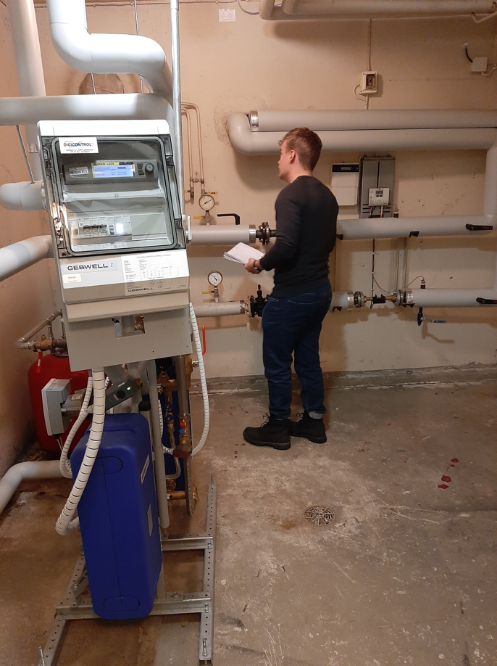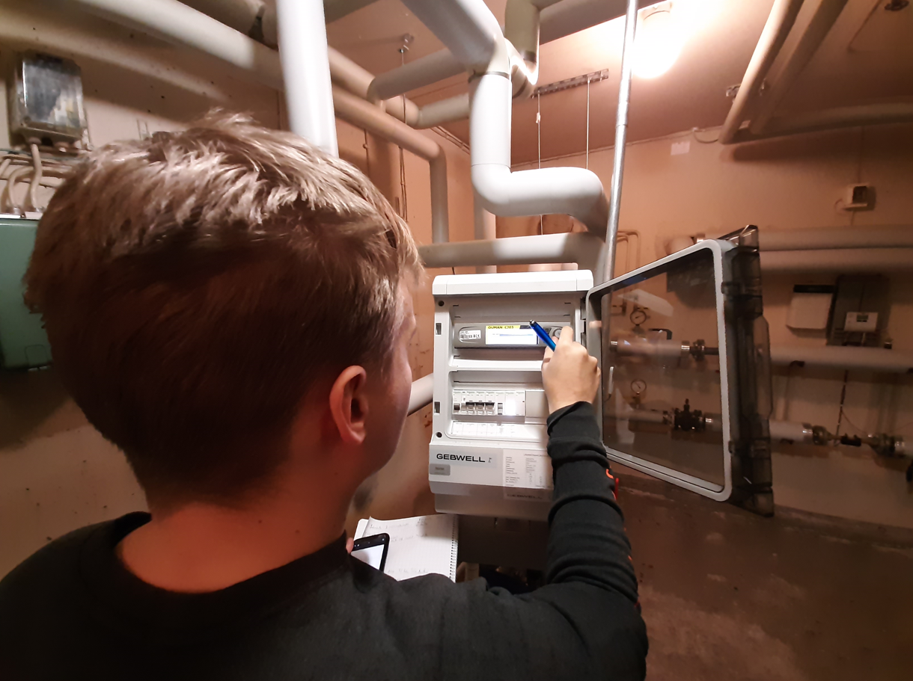

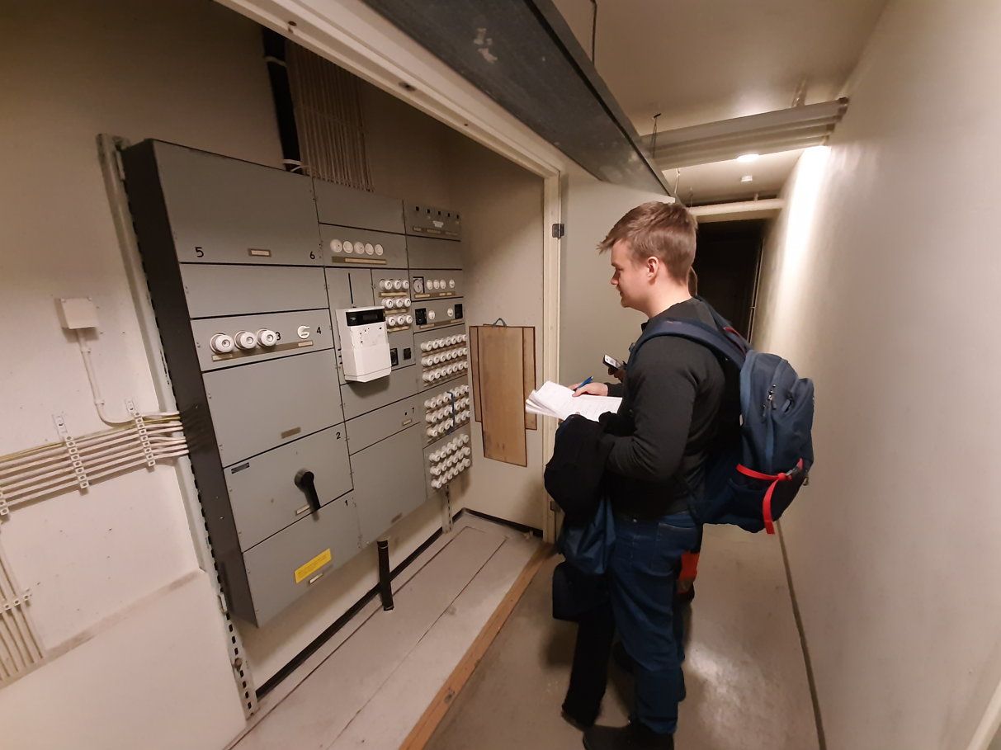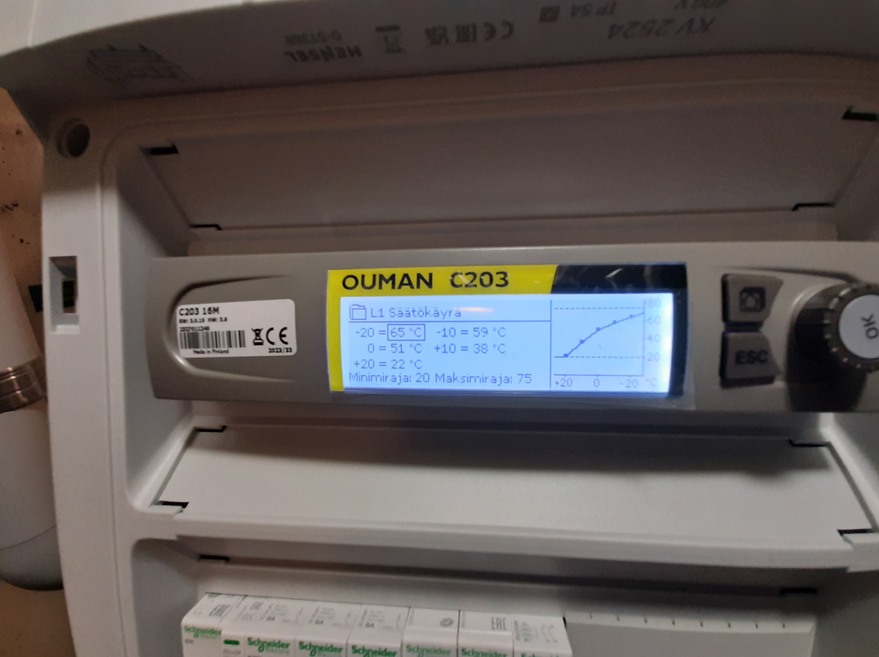

Link to the video available here: 20231114_130132.mp4

Analyse of energy audit results and decision of further activities

The final result of audits were reviewed on 22nd Jan 2024 at the local forum meeting, which was organized as hydrid event. After lively discussions the joint conclusion was that each board of housing association will decide latest until the end of Feb 2024, which of four suggested measures (one or more) they want to be proceeded as the group procurement.

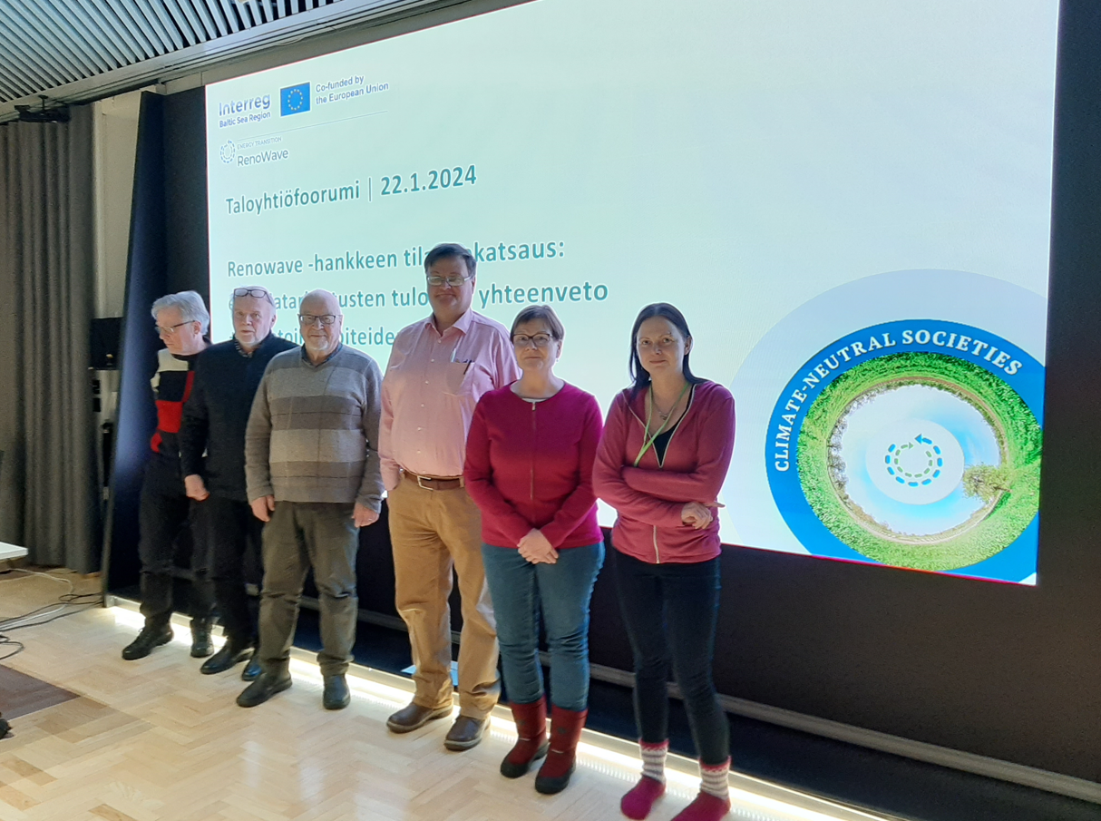

The next forum meeting was agreed to take place on 14th March 2024. On the meeting the main topic was to summarize the decisions made by each board. As the result, 11 forum members were still interested to promote group procurements. In two buildings who decided not to continue the process there were not reported such kind of measures, which could be implemented as group procurement. It was also decided that all four suggested measures will be promoted and further investigated, how to implementation could be carried out. For this purpose an external expert needed to be selected and tendering process was started to find a convenient supplier to draft a more detailed plan for implementation phase.

Tendering request for planning phase

Tendering request was sent to three potential suppliers in the middle of March and the selection of chosen expert was done at the end of March. The planning phase was expected to provide a detailed project plan. The translation of tendering request below:
The city of Lappeenranta is requesting a tender for the further planning of the investments proposed based the energy audits conducted at the end of 2023. Energy audits were carried out for 13 housing associations and four energy efficiency measures were proposed to be implemented as a group procurement:
1) Solar panel installation
2) Exhaust air heat pumps
3) Powered roof extractor
4) Renewing of heat exchanger equipments
The housing companies have formed their opinion on the proposed measures (more information at the end of the tender request). Based on these, the planning phase will be started and two separate offers will be requested for the implementation of this phase (below):
Option A: In the planning phase, all four proposed group procurement measures will be promoted. Option B: In the planning phase, measures 1 and 4 will be promoted as group procurement.
In both options A and B, the planning phase must contain at least:
- comparison of proposed investments
- preliminary cost and price estimates
- necessary ancillary work (e.g. execution of roof load-bearing calculations)
- the documents and reports required to start the implementation phase
- presentation of the financing sources and implementation options
- tendering and assisting in the selection of the service provider for the implementation phase
During the planning phase two workshops shall be organized together with housing associations.
As the final result of the planning phase, a project plan must be presented. The project plan identifies the measures to be conducted at the implementation phase of the group procurement and the costs for the measures, if the procurement is carried out for one housing association or as a group procurement for several housing associations.

The implementation of planning phase

The planning phase with chosen supplier started on 15th of April and target was the detailed plan would be ready to be presented latest in the end of June. A lot of additional information was needed to draft plans and a data request was sent to all group procurement participants to facilitate the planning process.

Based on received data, other relevant information and details gathered on-site -visits at each building the external experts drafted the plan for implementation phase with professional calculation tools. Below few photos and videos taken during site visits at Maininkikatu and Väinölänkatu.

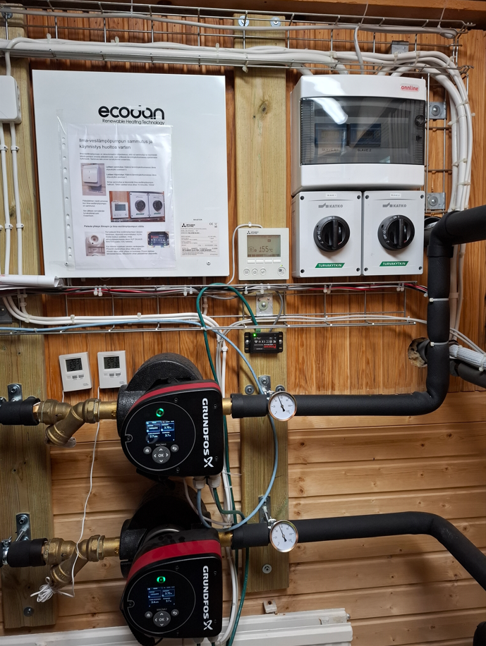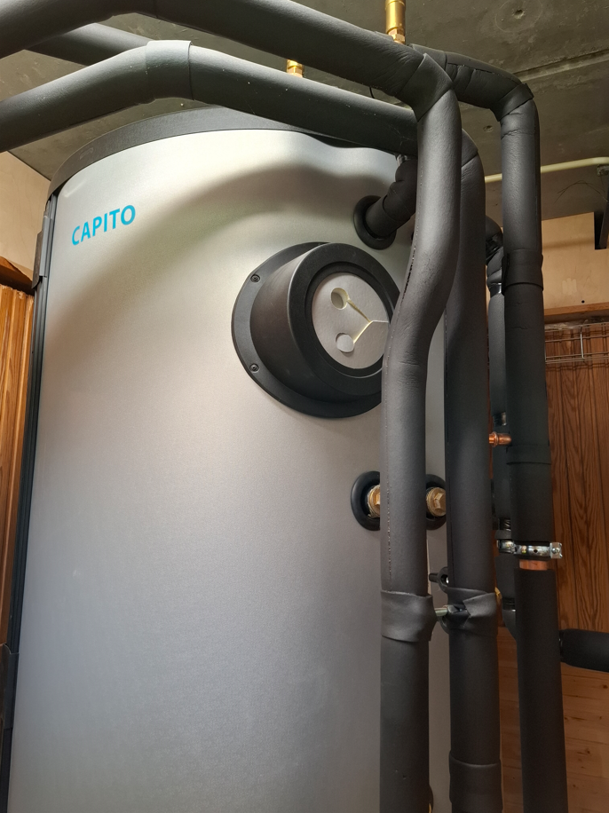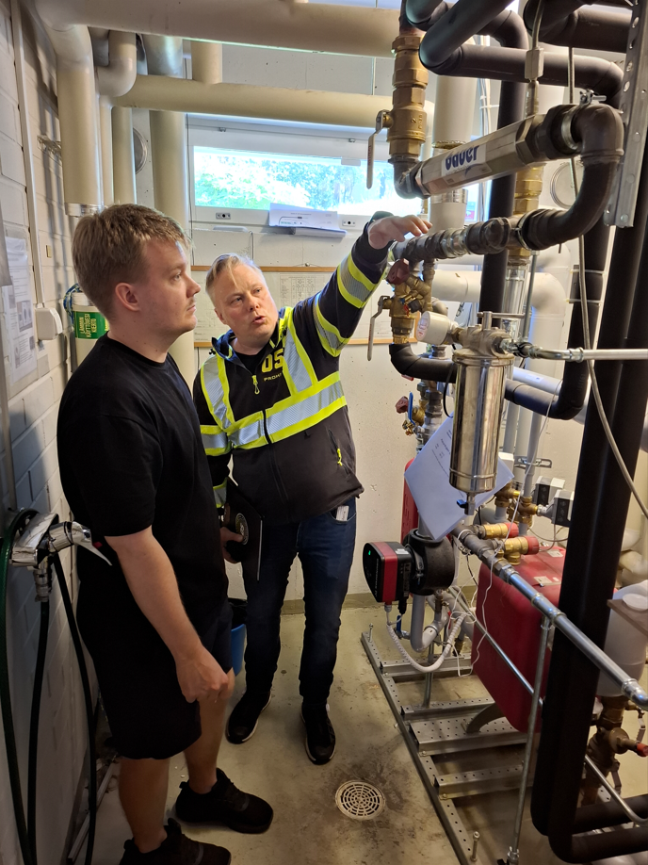

Link to the videos available here: 20240613_101619.mp4 and 20240613_102540.mp4

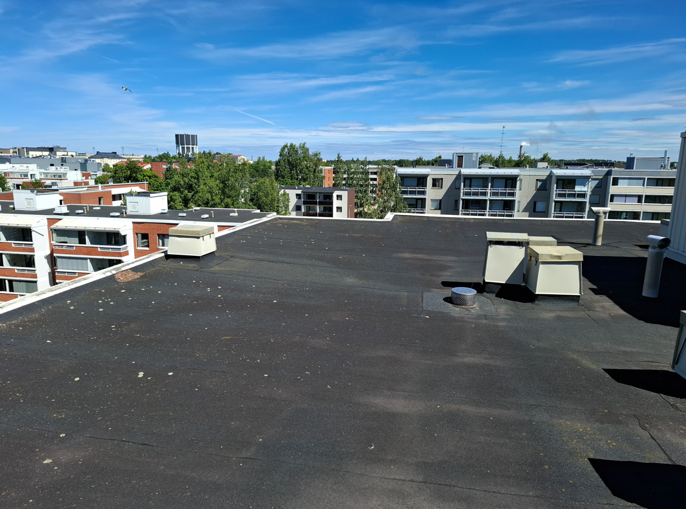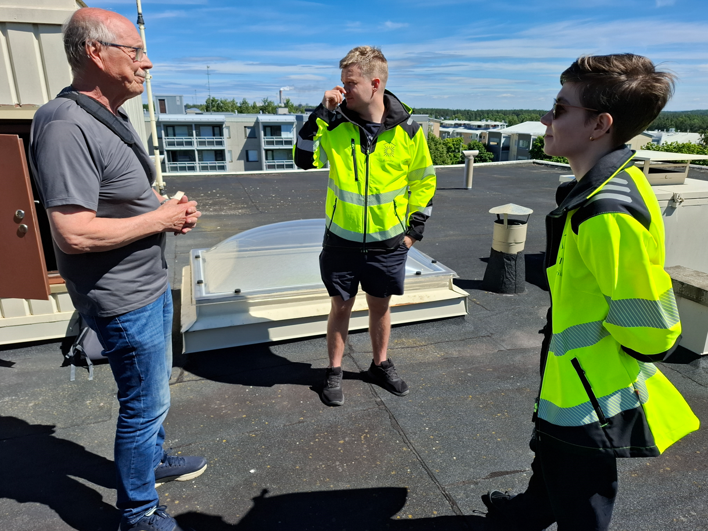

Link to the video available here: 20240625_130731.mp4

The first workshop during planning phase

The first workshop and status review of planning phase was organized on 29th May including rough estimation of investment costs and profitability calculations for each measures.

1) Powered roof extractors
2) Renewing of heat exchanger equipments
3) Exhaust heat pumps
4) Solar panel installation (both general building electricity and established energy community)

Each topic included very detailed presentation of the technical principles of equipment, preliminary price estimations and justification for the profitability calculations. Furthermore the planned next steps before the second workshop were introduced and agreed. These planned actions included the tendering process of all four planned measures (all as single procurement and group procurement) and own personal presentation of results for each participants.

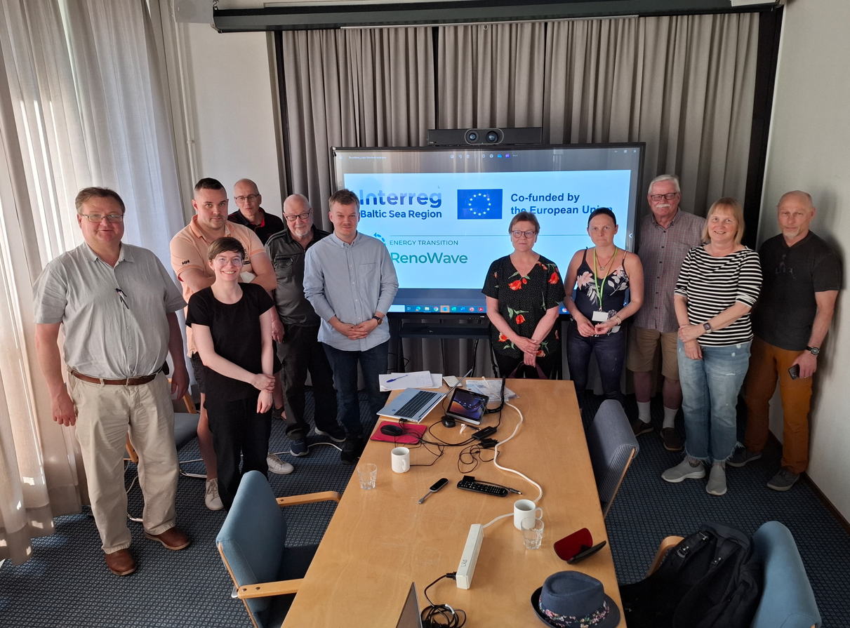

The second workshop during planning phase

The second workshop took place on 25th June including following topics:

1) Results of tendering process for each four measures
2) Financing and implementation of energy investments
a) financing options for housing associations
b) implementation options for housing associations
-ESCO services
-Leasing
-PPA, power purchase agreement
  - 3) How to proceed with investments? Discussions jointly

As the result of tendering requests, following number of tenders were received:

Number of tender requests sent / tenders received / tendering company name
1) Powered roof extractors: 3 / 1 / I-huolto Asennus Oy
2) Renewing of heat exchanger equipments: 5 / 3 / Cancera Oy , Espit Oy , Corecon Oy
3) Exhaust heat pumps: 4 / 2 / Nanea Oy , Proheat Oy
4) Solar panel installation: 5 / 2 / Novoka Oy , Nanea Oy

As the summary, the costs and potential saving-% as group procurement were following:

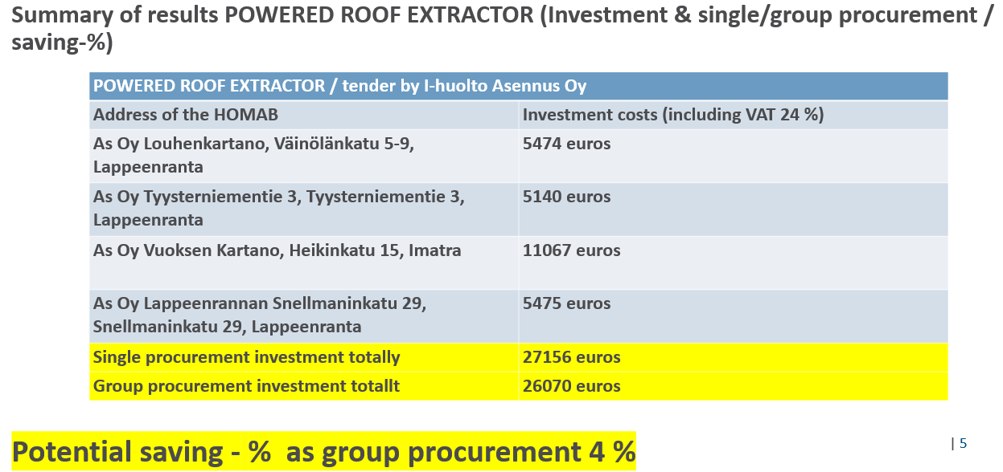

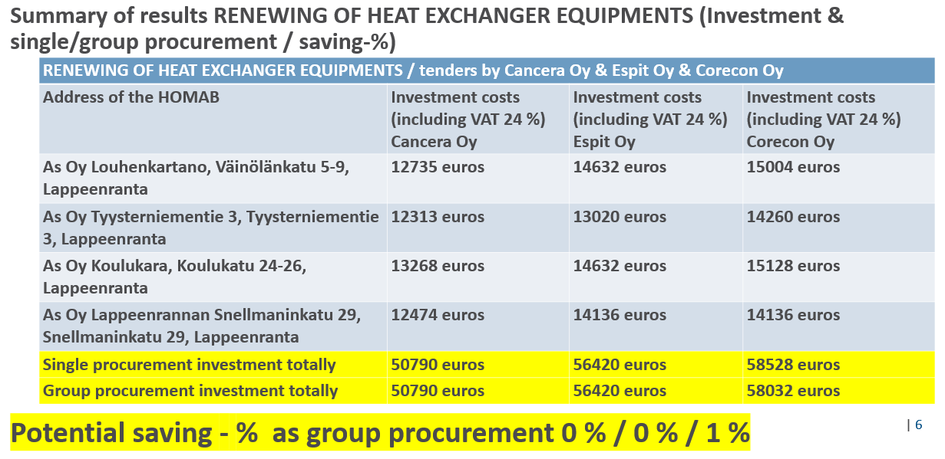

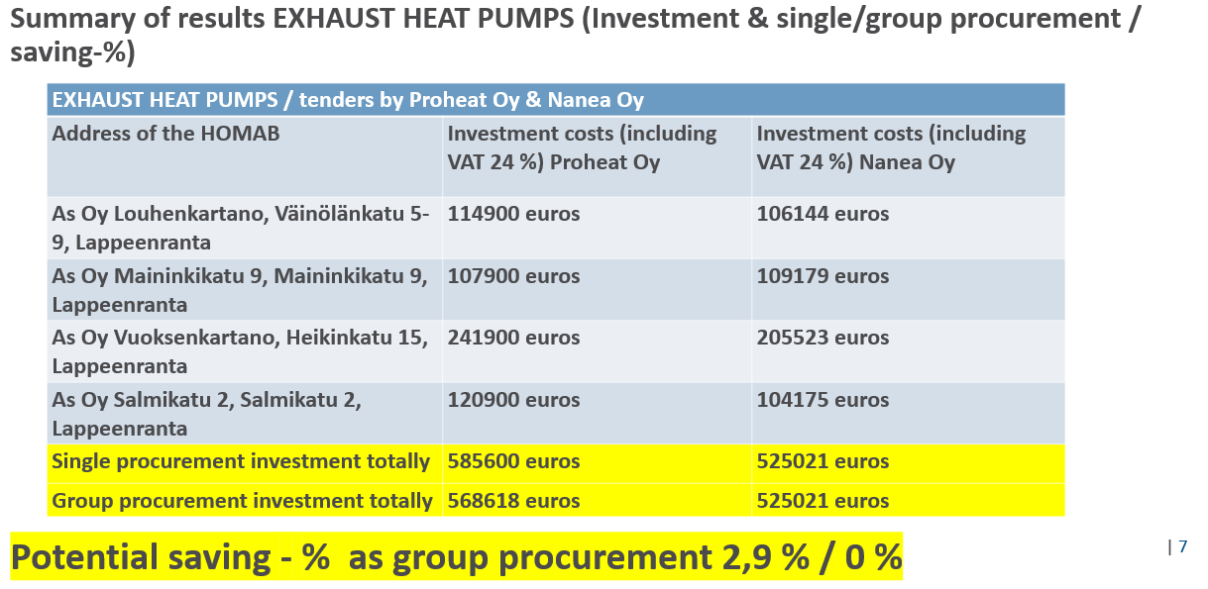

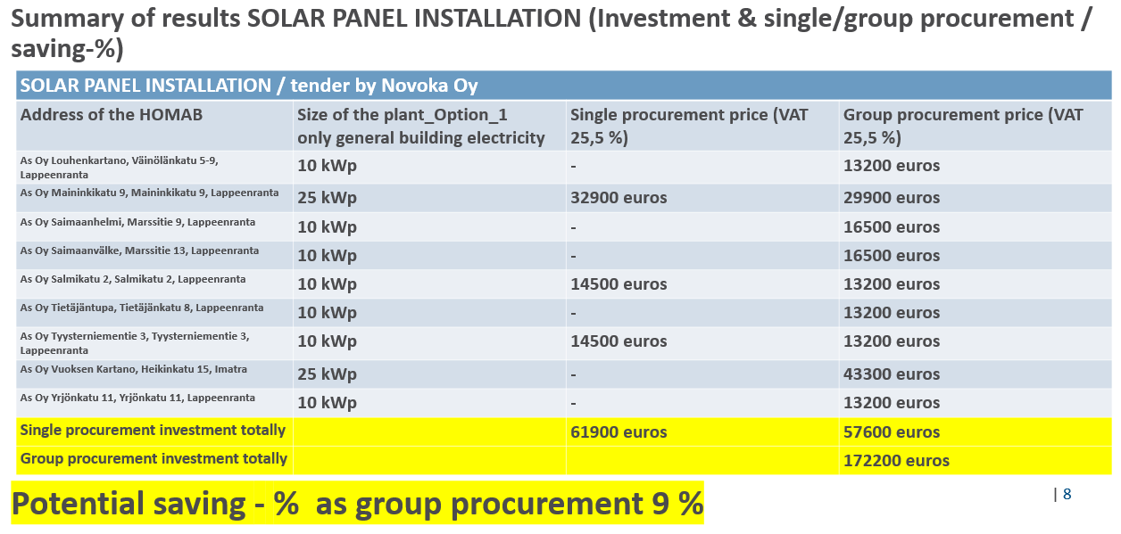

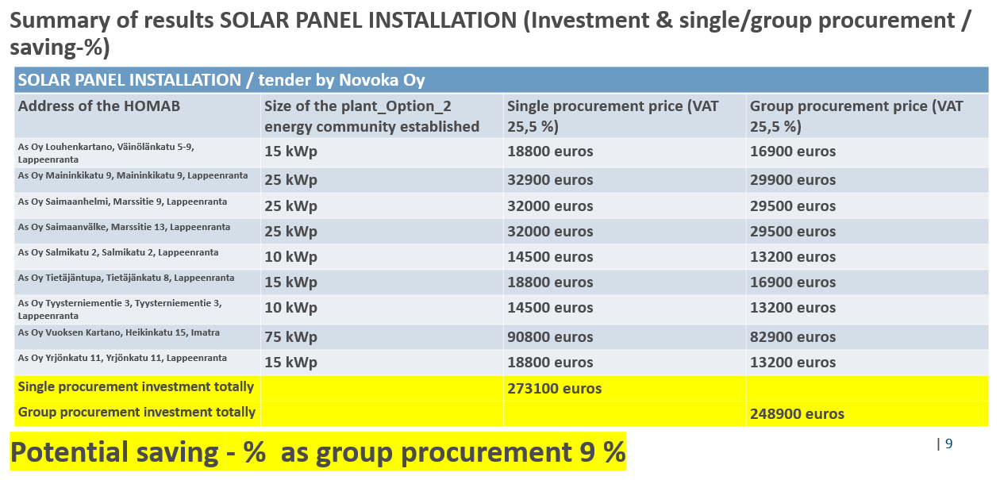

The most profitable measure according to tenders was installation of solar panels with saving potential of ~ 9 %, this potential was valid both for option_1 (only general building electricity) and option_2 (energy community established). In option_2 the plant sizes are bigger, because the produced energy is planned to be utilized also by apartments joining the energy community. For powered roof extractors the saving potential was approximately ~ 4 % and for exhaust heat pumps ~ 0…2,9 % and for renewing of heat exchanger equipments ~ 0…1 % depending on supplier. Also notable, that content of tenders vary between supplier, which means that prices are not directly comparable.

Furthermore comprehensive summary of funding possibilities were presented during the workshop.

After lively discussions at second workshop, it was decided that piloting housing associations will inform latest on 30th Sep, do they want continue the implementation of group procurements based on presented results.

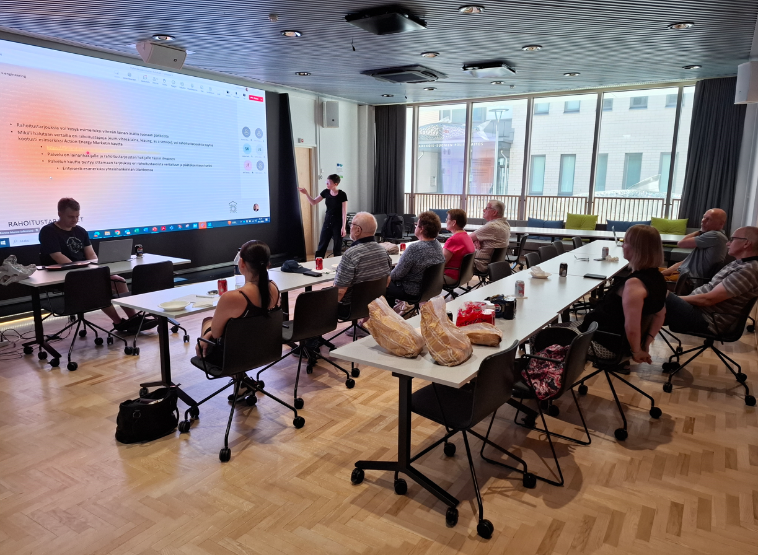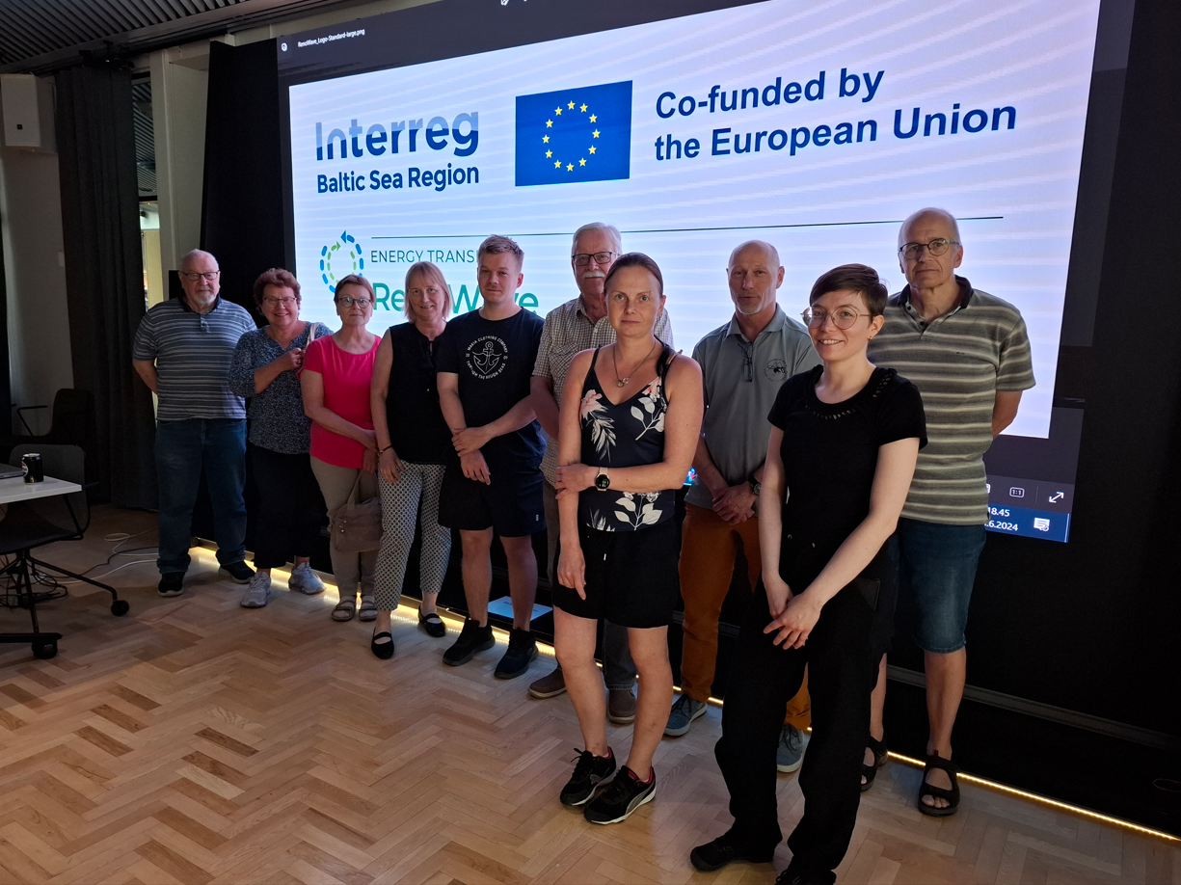

The forum meeting on 17th October

In the forum meeting at 17th Oct the feedback provided by housing associations were summarized. Three of them still were interested to continue: As Oy Vuoksen Kartano, As Oy Louhenkartano and As Oy Maininkikatu 9. The rest were no more interested and the main reasons not to continue, were following:

-potential saving-% is too low or there isn’t savings at all
-pay-back time too long
-HOMABs have prioritized other investment plans to be implemented
-several tenants in many apartments, the owner does not get any gain from solar panel investment

Current status at the end of November, 2024

Status review on 30th Nov, 2024: Renowave -project will exactly follow how the implementation phase continues by three housing associations mentioned above. Renowave -project is not able to support the practical implementation phase economically. Local energy advisors have agreed the regular follow-up, which means the implemented measures will be reported and communicated, when they have been finalized.

